Calum Kerr

REQUIREMENTS DEFINITION 3

Non-Functional Requirements 3

Functional Requirements 3

DATA DICTIONARY 3

FLOWCHART 4

IMPLEMENTATION 5

TESTING LOG 5

TECHNICAL GUIDE 6

APPENDICES 6

# REQUIREMENTS DEFINITION

## Non-Functional Requirements

* I use a language such as ‘HTML’ to make a website, and within it I use a second webpage scripting language called PHP. HTML which stands for “Hypertext Markup Language” and PHP stands for "Hypertext Preprocessor."
* The software required to develop the software is ‘notepad++’ and Xampp, which will execute PHP on local server.

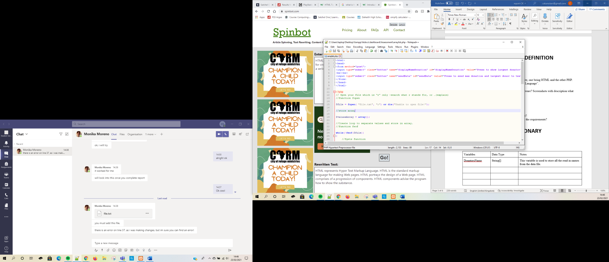

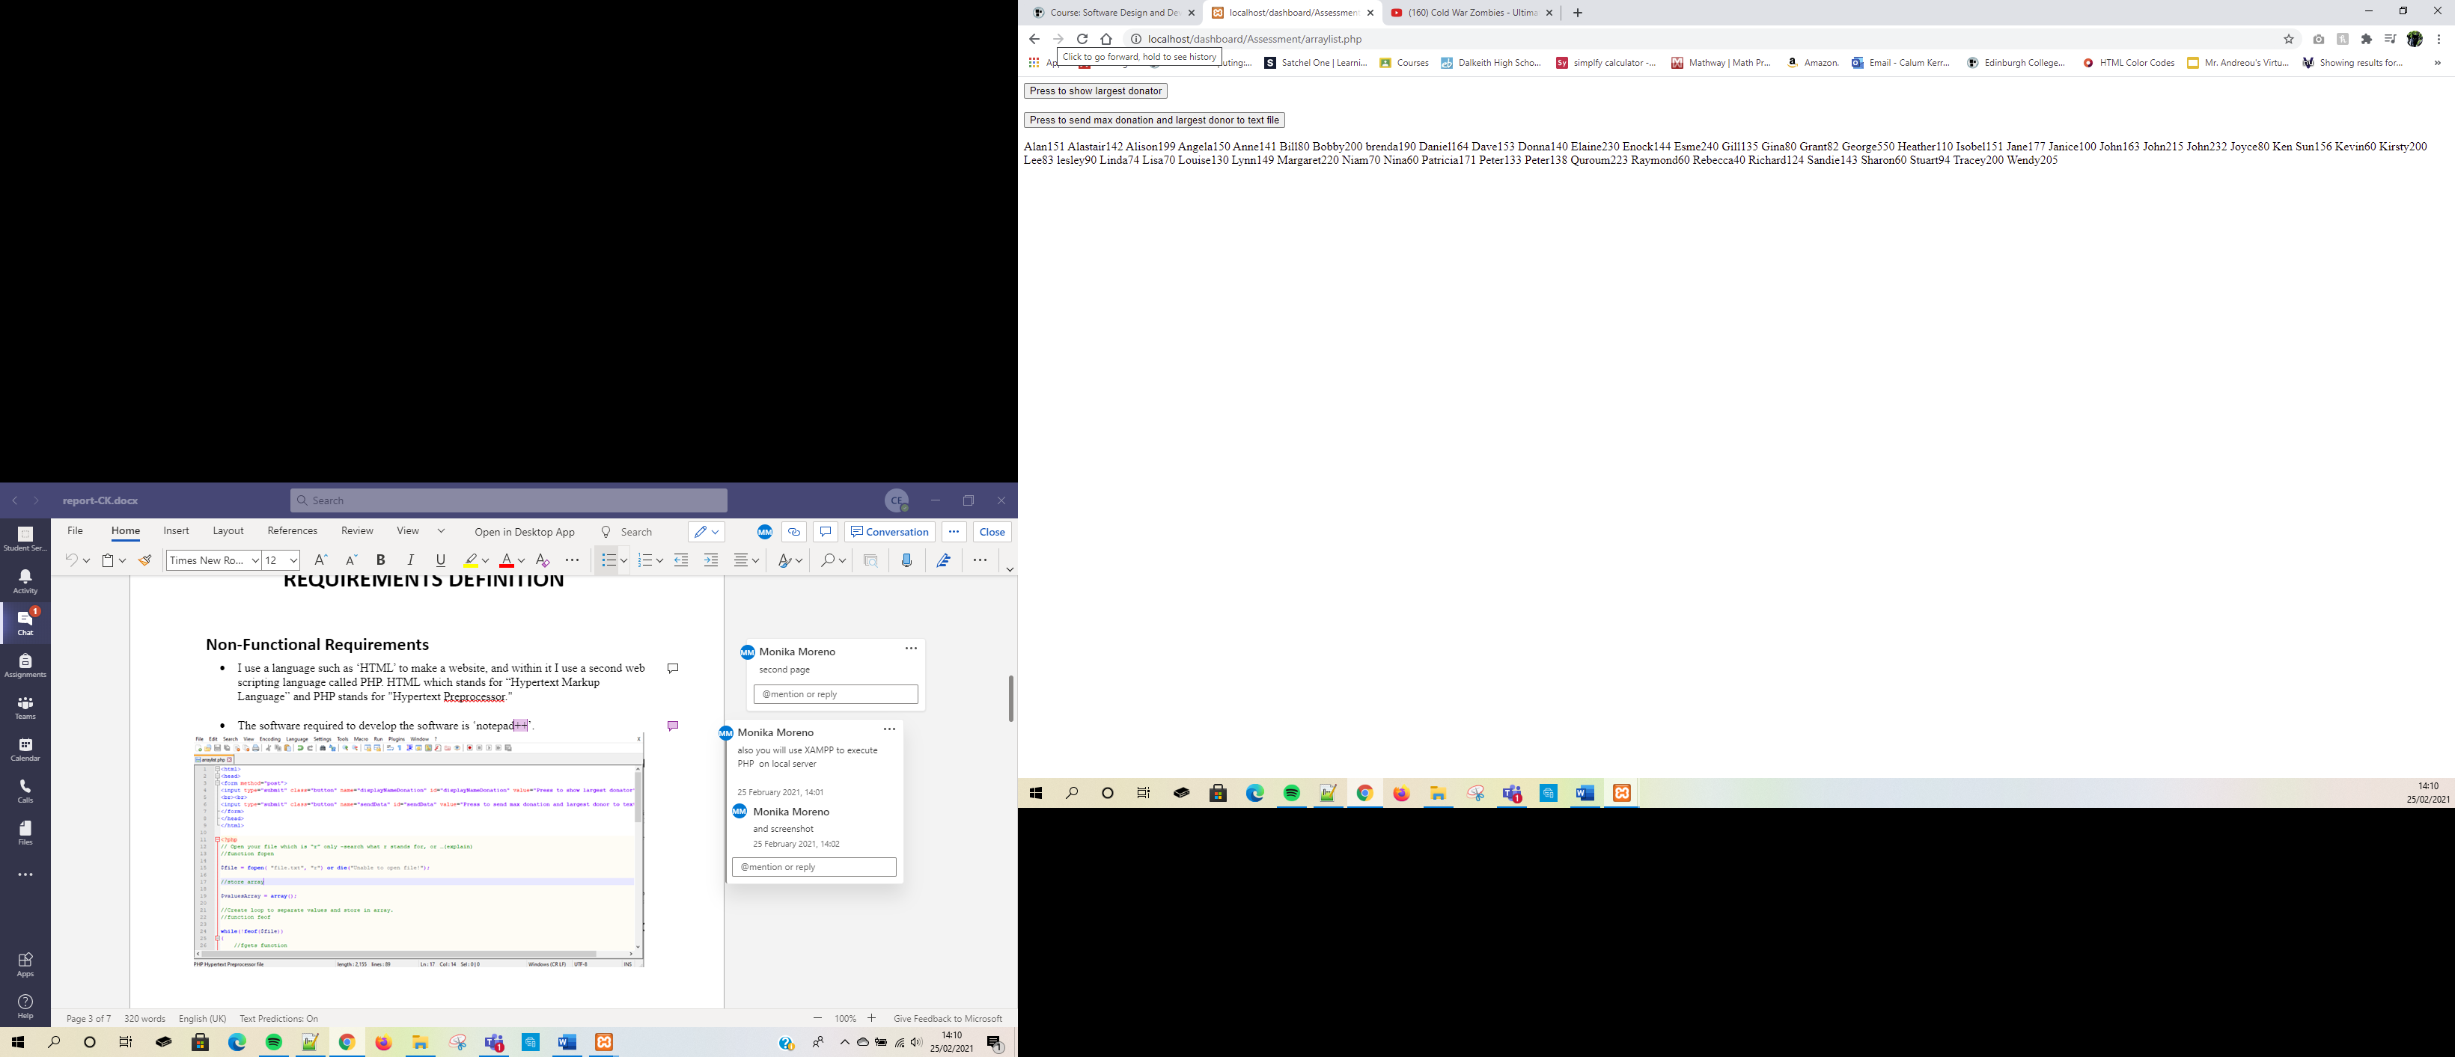

## Functional Requirements

* The programme was designed to, firstly read the text file which include all the names of everyone who donated and how much they donated. Then what the programme does is collect this information and displays who the top donator is and how much the person donated. Underneath this button is a second one that that when pressed it will send the max donation and largest donor to a text file. After opening this text file in your folder, you will then be able to see who the top donator is. Then below is a list of names of all the donators anti March they've donated in a table, in alphabetical order.
* The functions used within the PHP were “fopen”, what fopen() does is that it opens a file. The second function being “feof”, which reads the file can be opened. The third function “fgets”, which restores a line from an open document. The fourth function being “fclose”, which simply closes a file.

# DATA DICTIONARY

|  |  |  |
| --- | --- | --- |
| Variables | Data Type | Notes |
| DonatorsName | String[] | This variable is used to store all the read in names from the data file. |
| maxDonator | String[] | This variable is used to show who the max donator is out of them who donated. |
| valueArray | String[] | This variable is used to store the names and amounts of money into separate arrays. |
|  |  |  |

# FLOWCHART

Start

The script runs the html form.

Press to show largest donation.

Shows the top donator.

Press to send max donation and largest donor to text file.

Creates   
text file.

Shows all donators and how much they donated.

Shows who the highest donator. is.

# IMPLEMENTATION

When the programme is launched, you're taken to a web page and firstly you are given two options, one being “press to show largest donator” another option being “press to send max donation and largest donor to text file”. Underneath those two options is a table and in this table is a list of names in alphabetical order of everyone who has donated and besides the names is how much they have donated. When the button “press to show largest donator” is clicked, at the bottom of the webpage will pop up a name and that name will be the highest donator showing both their name and how much they’ve paid. When the button “press to send the max donation and largest donor to text file” is clicked it sends a file to your PC or hard drives folder and shows who the largest donator is in a simple PHP script.

# TESTING LOG

Name: Calum Kerr

Location: At home

Date: 04th March 2021

|  |  |  |  |  |
| --- | --- | --- | --- | --- |
| Test | Expected Action | Actual Action | Notes | Screenshot of actual action. |
| Clicking the button “Press to show largest donator”. | That when the button is pressed it will show who the largest donator is. | The programme performed as expected and the name of the largest donator it was shown | It's working fine however the name George appears twice. |  |
| Clicking the button “Press send max donation and largest donor to text file”. | When the button is clicked it will send the Max donation and largest donor to a text file in the same folder and will be accessible, and also showing the outcome with the name and donation. | The programme performed as expected what's it being in the file and the name and donation showing. | It ran perfect with no faults. |  |
| When the programme runs the names and the donations appear in a table, in alphabetical order. | The names and the donations are expected to be in a table in alphabetical order with the donations alongside the names. | The programme performed as expected. | It ran perfect with no faults. |  |
|  |  |  |  |  |
|  |  |  |  |  |
|  |  |  |  |  |
|  |  |  |  |  |

# TECHNICAL GUIDE

**Preparing data:**

There are 3 files:

* PHP – ‘arraylist.php’.
* Text doc – ‘file’.
* Text doc – ‘results’.

# APPENDICES

